

Application Design and Data Specification

Rustam Zazai, Reggie Brown

Professor Kyle Chapman

March 15th, 2026

COSC 2200-01

Contents
D3.1: System Architecture 3
D3.1.1: Framework 3
D3.1.2: Software Data Model 3
D3.1.3: Pre-existing Classes/Libraries 3
D3.1.4: Game State Use 4
D3.1.5: Well-known Design Patterns 4
D3.2: Class Diagram 5
D3.3: Data Specification 6
D3.3.1: Data Source Type 6
D3.3.2: Fields and Objects Stored 6
D3.3.3: Access Permissions and Security 7
D3.3.4: File Access and Class Responsibility 8
D3.3.5: OOP Concepts in Data Access 8
D3.3.6: Data Storage Within Program 8
D3.3.7: Level 1 Data Flow Diagram 9
D3.4: Asset List 10
D3.4.1: Graphics and Images 10
Maps 10
Player 10
Recruitable NPCs 11
NPCs 13
Enemies 15

D3.1: System Architecture

D3.1.1: Framework
The framework being used for our project is C# with Windows Forms App (.NET Framework). The reason this was selected was due to the team’s expertise with the framework.

D3.1.2: Software Data Model
Our project uses a 4-tier layered architecture:
- The presentation layer will be covered with the main window of our application, and the interaction and combat modals used to combat or communicate with NPCs.
- The business/application logic layer ensures coordination of business rules and logic with the user interface, which is achieved with our C# files.
- The domain/model layer consists of entities/objects, such as but not limited to: the player, hostile NPCs, friendly NPCs, items, inventory.
- The data layer exists due to the use of JSON for progress loading and saving.

D3.1.3: Pre-existing Classes/Libraries
Libraries we will be using in our project are:
- System.Text.Json - used for JSON serialization/deserialization.
- System.IO - used for file read/write operations.
- System.Media - used to play sounds.
- System.Drawing - used to display colors and images.
- System.Windows.Forms - the library required for WinForms.

D3.1.4: Game State Use
A game state is used. When the player first loads the application, their progress will be loaded if possible. The game state directly interacts with the player class to save the player’s information, the allies class to save the recruited allies, the inventory class to save the inventory, and a map class to save the player’s map level progression.

D3.1.5: Well-known Design Patterns
The project uses several well-known design patterns:
- Template method – our project will use a master class for NPCs and the player. One abstract method that will be overridden from the master class is the Die() method, which is overridden for both the player and the enemy.
- State – the game’s progression is dependent entirely on states; you can only advance through the game by exploring the map, succeeding during the combat state, viewing your inventory or allocating skills.
- Observer – UI controls subscribe to events, and when the events fire, the subscribed handlers are executed. This is used for our attack buttons, where if an attack sets an entity’s health below a threshold, the health bar color changes.
- Composite – the map is made of game maps, those game maps contain section which contain tiles. This meets the tree-like structure the pattern describes.

D3.2: Class Diagram
Allies in the game cannot be attacked or die, and that is why they do not inherit the organism class.
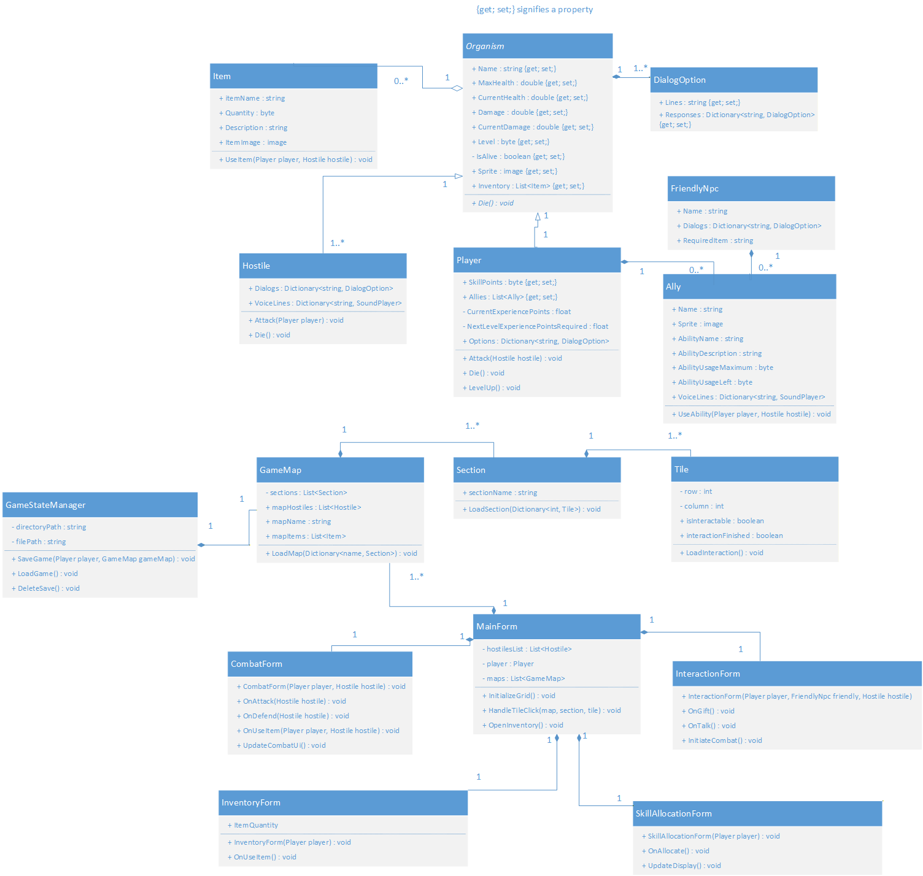

D3.3: Data Specification

D3.3.1: Data Source Type
The data source our project will use is a local JSON flat file. JSON was selected because:
- System.Text.Json is included by default in .NET.
- JSON files are easily readable.
- Our team has experience with JSON.
- Our professor’s slides on JSON is easy to understand and apply.
- JSON easily maps to objects.

D3.3.2: Fields and Objects Stored
Our project will save a single root object containing the following nested objects and fields:

PlayerData
Stores all the context required for the character to load the character.
- Level (byte)
- CurrentExperiencePoints (float)
- NextLevelExperiencePointsRequired (float)
- MaxHealth (double)
- CurrentHealth (double)
- Damage (double)
- SkillPoints (byte)
- Inventory (object list)
- Allies (object list)

InventoryData (nested inside PlayerData)
Stored a list for the items. Only the bare minimum required is stored because the item description or image can be derived from the name.
- Items (object list)
  - ItemName (string)
  - Quantity (byte)

AlliesData (nested inside PlayerData)
Stores a list for the items. All ally information will be retrieved from the name.
- Allies (object list)
  - Name (string)

MapProgress
The app only saves and loads data from the beginning of each map. All progress is loaded from a blank slate for each map.
- mapName (string)

D3.3.3: Access Permissions and Security
The save file is stored locally on the player’s machine in the application’s directory. The GameStateManager uses validation to prevent corruption of the application. Security in this app is greatly enforced through validation. We considered access permissions, but since our data is locally stored on the player’s machine, we allow modifications to the save files. If the GameStateManager cannot load the save correctly, the save file will be erased and a new game will start.

D3.3.4: File Access and Class Responsibility
All file operations are centralized in the GameStateManager class. The class reads, writes and validates the JSON save file. Saves happen once a map change occurs, and reads/loads happen when the app is launched.

D3.3.5: OOP Concepts in Data Access
The data layer utilizes OOP concepts in these ways:
- JsonSerializer is used to map the classes for saving and loading. The data layer is kept separate from the domain layer with the use of GameStateManager.
- Encapsulation is implemented since the GameStateManager class encapsulates all logic to save and load data.
- Abstraction is proven by exposing only what is necessary. The GameStateManager has a directoryPath string which is private, in addition to the filePath srting which is also private. Only code that is required is exposed, which includes methods such as SaveGame, LoadGame and DeleteSave.

D3.3.6: Data Storage Within Program
The player information is stored as a single object which holds generic lists for the number of allies recruited and the inventory. Items are stored for the player as “List<Item>”, where Item is a class, the same method is used for the allies recruited, which is “List<Ally>”. The number of sections is stored as a list, in addition to the hostiles. The dialog options “Dictionary<string, DialogOption>” and voice lines “Dictionary<string, SoundPlayer>” are stored as a dictionary since I felt it was easier to understand with the keys. The tiles are also stored as a dictionary as it would make them easier to work with “Dictionary<int, Tile>”.

D3.3.7: Level 1 Data Flow Diagram

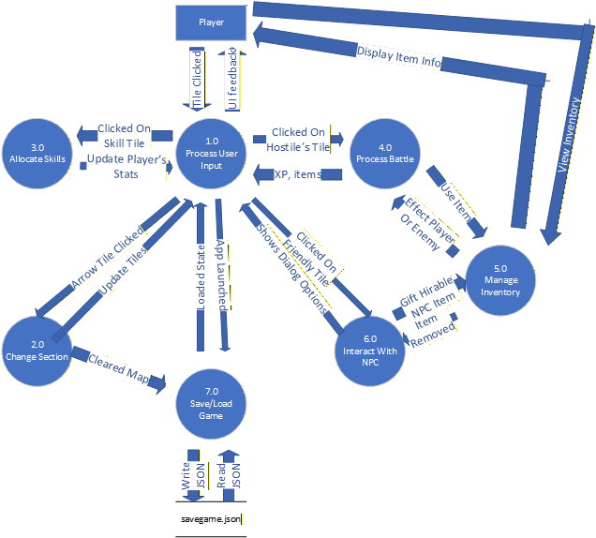

D3.4: Asset List

D3.4.1: Graphics and Images
Our project uses many external images and sounds. We use only .NET framework libraries. Also, we do not use external fonts. Included is what we plan to use, if we decide to modify any of our choices, it will be reflected unto this document. All assets are copyrighted and used purely for non-commercial academic purposes.

Maps
Map 1: https://www.reddit.com/r/Minecraft/comments/1nee3zc/since_100_plains_biomes_have_been_able_to_generate/
Map 2: https://cdn.wikimg.net/en/strategywiki/images/8/82/Pokemon_FRLG_Pallet_Town.png
Map 3: https://i.pinimg.com/originals/10/64/92/1064925e6d703b57531b6779432b3567.jpg

Player
Player (
Player died noise
https://www.youtube.com/watch?v=5tWfHcn7PiM
https://www.youtube.com/watch?v=PP7WJL2JtLs
Player take damage noise
https://www.youtube.com/watch?v=PVqlk3BO_C4 1:28-1:30 )

Items
First Aid Spray:
https://static.wikia.nocookie.net/residentevil/images/f/fb/First_Aid_Spray_(Resident_Evil_2_(2019)).png/revision/latest/scale-to-width-down/124?cb=20220225042439
Diamond:
https://share.google/9gBOLkRwphBgzvGaB

Recruitable NPCs
Siegward
(
Images
InteractionIcon :
https://static0.thegamerimages.com/wordpress/wp-content/uploads/2020/06/Dark-Souls-3-siegward-armor.jpg?q=50&fit=crop&w=825&dpr=1.5
SpriteIcon
https://a.thumbs.redditmedia.com/lIoRBVVKMxNEnn3gRq52e_oUqeAcaY083Ji3sAuHrQ8.jpg
Sounds
RecruitmentSound:
http://youtube.com/watch?v=4nyMhe6MYYk 4:53-5:00
AbilityUsedSound:
https://www.youtube.com/watch?v=fWA-TtPwKWc 0:05-0:07

ItemRequired – Siegbräu:
https://www.eliteguias.com/img/juegos/dark-souls-iii/siegbrau.jpg
)

Solaire
(
Images
InteractionIcon:
https://lokeysouls.com/wp-content/uploads/2023/03/solairesunpraise.jpg?w=1024
SpriteIcon
https://static.wikia.nocookie.net/darksouls/images/2/21/DS1R_Solaire_of_Astora_in_Undead_Burg_(half_body,_front).webp/revision/latest/scale-to-width-down/268?cb=20231127191535
Sounds
RecruitmentSound:
https://www.youtube.com/results?search_query=ds1+solaire+questline 3:12-3:16
AbilityUsedSound
https://www.youtube.com/watch?v=p9sspAezwJE 0:17-0:20
ItemRequired - Sunlight Medal:
https://darksouls3.wiki.fextralife.com/file/Dark-Souls-3/SunlightMedal.PNG
)

NPCs

BritneySpears
(

Images
InteractionIcon:
https://fummas.bandcamp.com/track/britney-spears-toxic-fummas-remix
SpriteIcon:
https://www.vogue.com/article/britney-spears-toxic-music-video-anniversary

Sounds
RecruitmentSound:
https://www.youtube.com/watch?v=CduA0TULnow&list=RDCduA0TULnow&start_radio=1 2:19-2:22

ItemRequired – Diamond
https://share.google/9gBOLkRwphBgzvGaB
)

FireKeeper (
Images
InteractionIcon:
https://i.pinimg.com/originals/4d/a2/12/4da212c68befab632e0c699bbcf9fd48.jpg
SpriteIcon
Sounds
DuringLeveling:
https://www.youtube.com/watch?v=Bfv0u6DYG6c
)

Sphinx (
Images
InteractionIcon:
https://preview.redd.it/the-sphinx-scene-from-the-dd2-trailer-but-with-more-of-the-v0-ps86fx0jym4c1.png?width=640&crop=smart&auto=webp&s=a4b8d6169d32cbd1e0b4a2d5ad1d049d5a948d68
SpriteIcon:
https://images.pushsquare.com/14f4f2a880357/dragons-dogma-2-all-sphinx-riddle-answers-locations-and-rewards-21.900x.jpg
ItemGiven – Sunlight Medal:
https://darksouls3.wiki.fextralife.com/file/Dark-Souls-3/SunlightMedal.PNG
)
DarkSunGwndolyn (
Images
InteractionIcon:
https://i.pinimg.com/originals/71/04/75/71047524b221e83cc564788db34ee663.jpg
SpriteIcon:
https://preview.redd.it/any-tips-on-dark-sun-gwyndolin-having-a-really-tough-time-v0-g1rai7g8o7f91.jpg?width=640&crop=smart&auto=webp&s=37449694e09ffe364854c6c33ffa70c9eb1a6815
)

Enemies
Regenerator - section enemy (
Images
InteractionIcon:
https://static0.gamerantimages.com/wordpress/wp-content/uploads/2021/07/resident-evil-4-re4generators-mod.jpg?q=50&fit=crop&w=825&dpr=1.5
SpriteIcon:
https://www.youtube.com/watch?v=Ejph5MLeE98 4:21
Sounds
EnemyDeath:
https://www.youtube.com/watch?v=Ejph5MLeE98 7:45-7:47
EnemyCriticalHit: https://www.youtube.com/watch?v=7YUU4FHsw9w )
Dr Salvador - section enemy (
Images
InteractionIcon:
https://p1.hiclipart.com/preview/777/29/113/dr-salvador-chainsaw-re4-professional-render-illustration-of-masked-man-holding-bloody-chainsaw-png-clipart.jpg
SpriteIcon:
https://www.evilresource.com/images/data/full/re4/dr-salvador.png?fcfde79a
Sounds
EnemyDeath:
https://www.youtube.com/watch?v=XAVnysraLe0 0:20-0:22
EnemyCriticalHit:
https://www.youtube.com/watch?v=XAVnysraLe0 0:23-0:27

BigDaddy - section enemy (
Images
InteractionIcon
https://www.indy100.com/media-library/next-level-play-postmark-it-news-bioshock-4-location.jpg?id=55424349&width=1245&height=700&quality=50&coordinates=0,94,0,95
SpriteIcon:
https://preview.redd.it/out-of-the-five-types-of-big-daddies-in-the-series-whats-v0-68ys87nw5vu71.png?width=1000&format=png&auto=webp&s=e3d805ca175fd21c2a88c465e97da4e7caeb45b7
Sounds
EnemyDeath:
https://www.youtube.com/watch?v=EjMkfq6K7cw 1:00-1:02
EnemyCriticalHit:
https://www.youtube.com/watch?v=FuZXcp-btN0 1:05-1:08
)
Nemesis - map boss (
Images
InteractionIcon:
https://static.wikia.nocookie.net/residentevil/images/8/8f/RE3_remake_Nemesis_key_visual.png/revision/latest/scale-to-width-down/268?cb=20200114174538
SpriteIcon:
https://preview.redd.it/going-to-start-re3-nemesis-for-the-first-time-any-tips-and-v0-4njqgidfqry71.jpg?width=640&crop=smart&auto=webp&s=f90bd25dceb42c384b998aac01223e182eaf2342
Sounds
EnemyDeath:
https://www.youtube.com/watch?v=1LxTl0QfARs 1:13-1:15
EnemyCriticalHit:
https://www.youtube.com/watch?v=0zd1y3fczQ0 0:36-0:39)

Verdugo - section enemy (

Images
InteractionIcon:
https://preview.redd.it/i-think-verdugo-from-re4-has-one-of-the-coolest-and-most-v0-0376zax29xb41.png?auto=webp&s=d9ef8e703f8123c3b3d04852c1ecda7e21412cc4
SpriteIcon:
https://preview.redd.it/out-of-all-the-unique-and-terrifying-monsters-in-re4-the-v0-ku0dkyknluu91.jpg?width=640&crop=smart&auto=webp&s=ee8ebd0824b6239e8f870794436d2fdab88cdf28

Sounds
EnemyDeath:
https://www.youtube.com/watch?v=-_MEldnLOPY 8:59-9:01
EnemyCriticalHit:
https://www.youtube.com/watch?v=-_MEldnLOPY 7:45-7:45
)

Nameless King - map boss(
Images
InteractionIcon:
https://i.pinimg.com/originals/88/19/91/8819916a88c41c424cbc47bc9a179b8d.jpg
SpriteIcon:
http://darksouls3.wdfiles.com/local--files/boss-image:nameless-king/Nameless_King.jpg
Sounds
EnemyDeath:
https://www.youtube.com/watch?v=SyFNPZN82kg 5:10-5:15
EnemyCriticalHit:
https://www.youtube.com/watch?v=SyFNPZN82kg 3:34-3:35
)

Hercules - section enemy(
Images
InteractionIcon:
https://i.ytimg.com/vi/tNaCwu_rV0k/maxresdefault.jpg
SpriteIcon:
https://static.wikia.nocookie.net/villains/images/b/b1/God-of-war-3-001.jpg/revision/latest/scale-to-width-down/150?cb=20100714030512
Sounds
EnemyDeath:
https://www.youtube.com/watch?v=PP7WJL2JtLs
EnemyCriticalHit:
https://www.youtube.com/watch?v=giRW8rWxSPU 2:26-2:27
)

Kratos - map boss(
Images
InteractionIcon:
https://godofwar.fandom.com/wiki/Kratos
SpriteIcon:
https://share.google/uBjMNdipiSYCLpGmD
Sounds
EnemyDeath:
https://www.youtube.com/watch?v=u0EsOjHhuRs 23:25-23:27
EnemyCriticalHit
https://www.youtube.com/watch?v=Q6dsPGh_xVs 15:10-15:12
)

